PROJECT TITLE:- Calendar Application

NAME :- Shivayush Mohan

REG NO :- RA2111002010032

DEPARTMENT :- Mechanical (A)

SUBMITTED TO

DR. R. RAJKUMAR

DSBS

SCHOOL OF COMPUTING

SRMIST

JANUARY 2022

ABSRACT :-

Basically three operations can be done in this calendar application. To find out the day corresponding to a given date, the date, month and year are asked. You can list the days and dates of any month of any year. For example, entering 04 2014 (April 2014) will give you an output as shown in the screenshot in this post.

You can navigate the months using arrow keys, or press ‘n’ and ‘p’ keys to view the next and previous months respectively. The third feature of this C mini project on Calendar application utilizes file handling. With this feature, you can add important notes with corresponding dates.

FLOW CHART

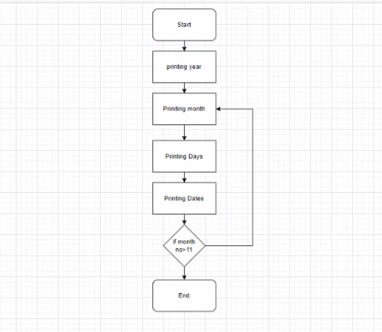

PROGRAM

// C program to print the month by month

// calendar for the given year

#include <stdio.h>

// Function that returns the index of the

// day for date DD/MM/YYYY

int dayNumber(int day, int month, int year)

{

static int t[] = { 0, 3, 2, 5, 0, 3,

5, 1, 4, 6, 2, 4 };

year -= month < 3;

return (year + year / 4

- year / 100

+ year / 400

+ t[month - 1] + day)

% 7;

}

// Function that returns the name of the

// month for the given month Number

// January - 0, February - 1 and so on

char\* getMonthName(int monthNumber)

{

char\* month;

switch (monthNumber) {

case 0:

month = "January";

break;

case 1:

month = "February";

break;

case 2:

month = "March";

break;

case 3:

month = "April";

break;

case 4:

month = "May";

break;

case 5:

month = "June";

break;

case 6:

month = "July";

break;

case 7:

month = "August";

break;

case 8:

month = "September";

break;

case 9:

month = "October";

break;

case 10:

month = "November";

break;

case 11:

month = "December";

break;

}

return month;

}

// Function to return the number of days

// in a month

int numberOfDays(int monthNumber, int year)

{

// January

if (monthNumber == 0)

return (31);

// February

if (monthNumber == 1) {

// If the year is leap then Feb

// has 29 days

if (year % 400 == 0

|| (year % 4 == 0

&& year % 100 != 0))

return (29);

else

return (28);

}

// March

if (monthNumber == 2)

return (31);

// April

if (monthNumber == 3)

return (30);

// May

if (monthNumber == 4)

return (31);

// June

if (monthNumber == 5)

return (30);

// July

if (monthNumber == 6)

return (31);

// August

if (monthNumber == 7)

return (31);

// September

if (monthNumber == 8)

return (30);

// October

if (monthNumber == 9)

return (31);

// November

if (monthNumber == 10)

return (30);

// December

if (monthNumber == 11)

return (31);

}

// Function to print the calendar of

// the given year

void printCalendar(int year)

{

printf(" Calendar - %d\n\n", year);

int days;

// Index of the day from 0 to 6

int current = dayNumber(1, 1, year);

// i for Iterate through months

// j for Iterate through days

// of the month - i

for (int i = 0; i < 12; i++) {

days = numberOfDays(i, year);

// Print the current month name

printf("\n ------------%s-------------\n",

getMonthName(i));

// Print the columns

printf(" Sun Mon Tue Wed Thu Fri Sat\n");

// Print appropriate spaces

int k;

for (k = 0; k < current; k++)

printf(" ");

for (int j = 1; j <= days; j++) {

printf("%5d", j);

if (++k > 6) {

k = 0;

printf("\n");

}

}

if (k)

printf("\n");

current = k;

}

return;

}

// Driver Code

int main()

{

int year = 2044;

// Function Call

printCalendar(year);

return 0;

}

RESULTS

SCREENSHOTS :-

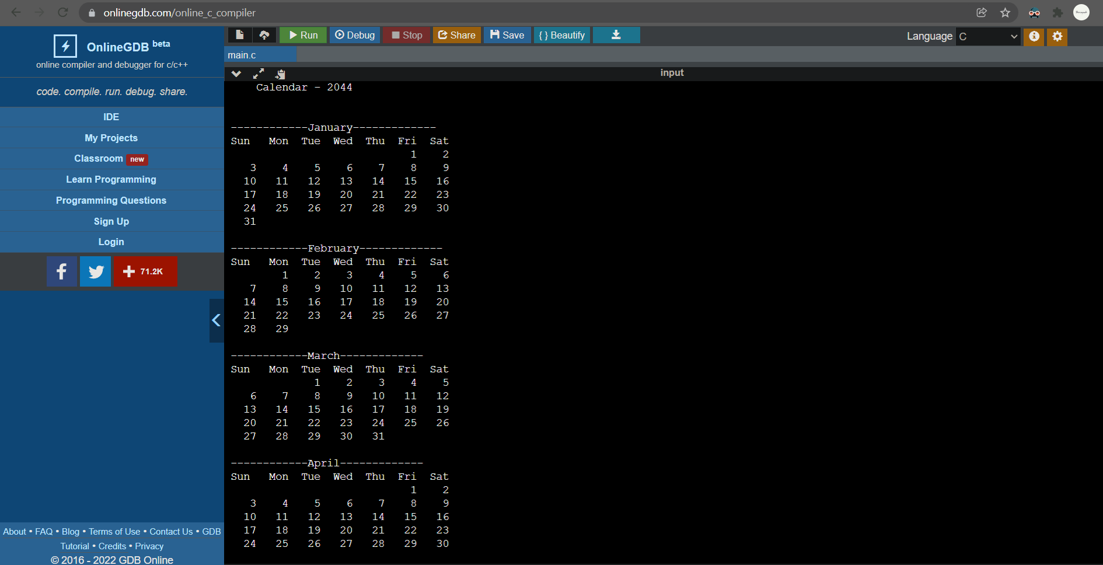

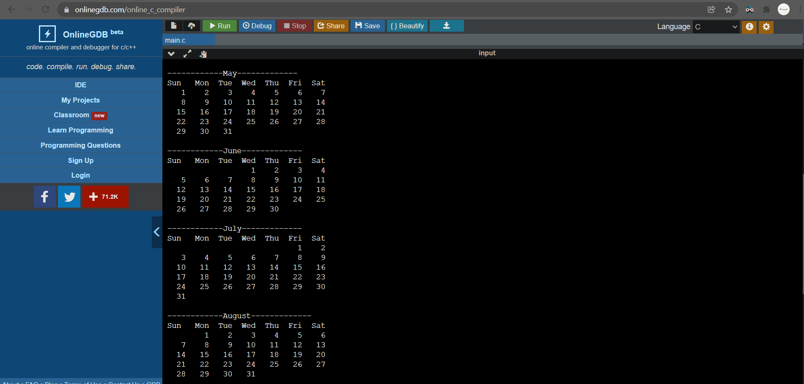

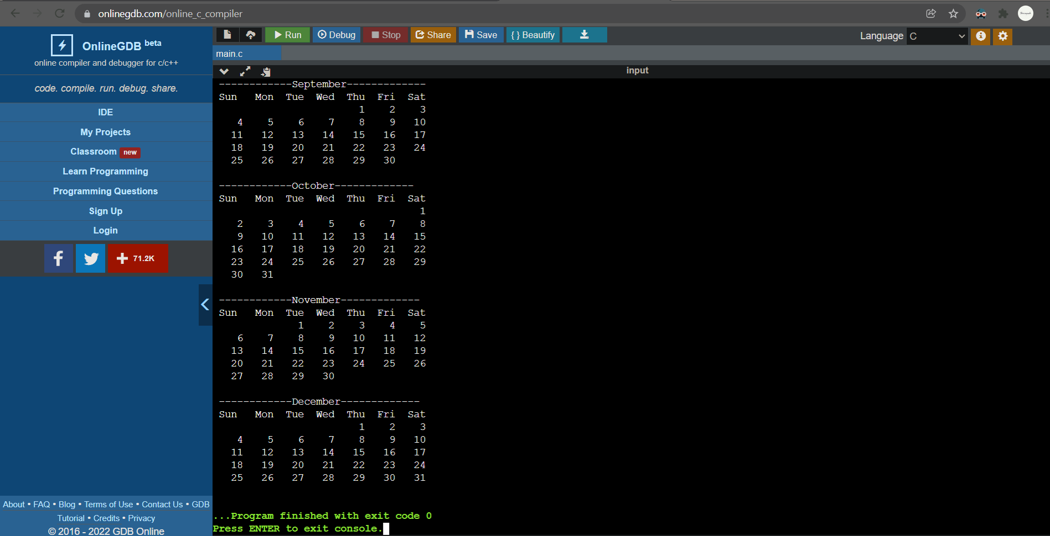

DECLARATION :- Thanking our Programming for Problem Solving professor Dr . R. Rajkumar for his help, advice and support.

Special thanks to SRM University for giving us this opportunity so show case our

Abilities.

RERERENCES :-

www.codewithc.com